RESIDENT HANDBOOK
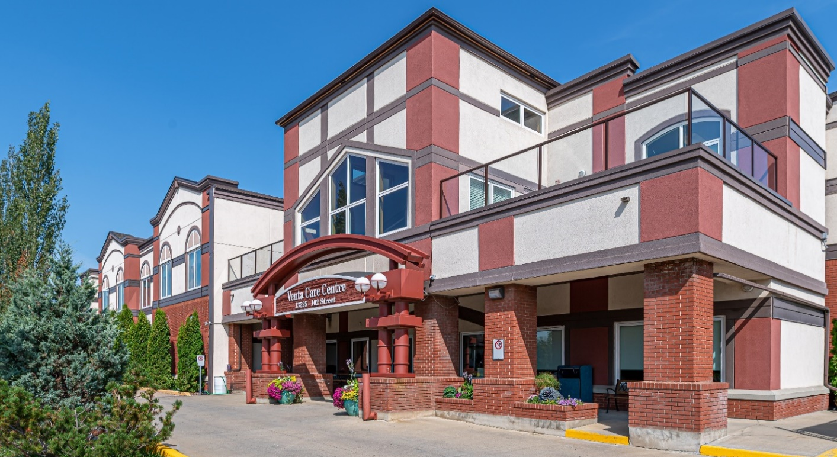


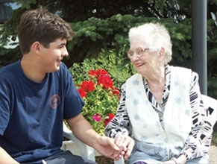
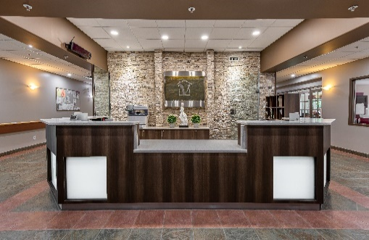

“To Provide Family Focused Care with Respect and Dignity”

Owned and Operated by the Birzgalis Family Since 1953



RESIDENT HANDBOOK

CONTENTS
Revised June, 2026

Welcome 1
Accreditation 2
Venta Care Centre Mission, Vision, Values 3
Resident Rights and Responsibilities 4
Room and Accommodation 5
Accommodation Rates 5
Resident Rooms 5
Courtyards 6
Resident Belongings 6
Hearing Aids 7
Eyeglasses / Dentures 7
Clothing 8
Personal Care Items 9
Tuck Cart 9
Mobility Supports and Devices 9
Incontinent Products 10
Resident Comfort Fund / Money 10
Admission Process 10
Attending Physician 10
Nursing 10
Registered Dietitian 10
Occupational Therapy 11
Recreational Therapy 11
Social Worker 11
Food / Nutrition Services 11
Menus 11
Dining Rooms / Meal Service 12
Snacks and Beverages 13
Personal Fridges 13
Bringing in Food or Alcohol 13
Visitation 14
Visiting Hours 14
Facility Access 14
Visitor Sign In / Out 15
Parking 15
Resident and Family Lounges 15
Pets 15
Visitor Safety 16
First Aid Station 16
Fire Drills 16
Evacuation Maps 16
Smoke Free Environment 16
Signage 16
Security Cameras 16
Workplace Violence & Harassment 16
Hazard Reporting 17
Infection Prevention & Control 17
Hand Hygiene 17
Personal Protective Equipment 17
Vaccines 17
Outbreak Protocols 18
Outings 18
Facility Leave 18
Transportation and Accompaniment 19
Gifts and Gratuities 19
Resident Safety 19
Falls 19
Call Bell or Pendant 20
Managed Risk Agreements 20
Bathing 20
Restraints 20
Identification Bracelets & Photos 20
No Abuse Tolerance Policy 21
Communication & Processes 21
Care Conferences 21
Newsletters 22
Resident and Family Council 22
Policies and Procedures 22
Resident Safety Disclosure 22
Services 23
Front Desk / Reception 23
Foot Care 23
Pharmacy 23
Dental 24
Optical and Hearing Aid 24
Laboratory Services 24
X-Ray Services 24
Hair Salon / Barber 24
Resident Telephone 24
Cable Television 25
Newspaper 25
Mail / Deliveries 25
Laundry Services 25
Housekeeping Services 25
Maintenance Services 26
Volunteers 26
Pastoral Care Services 26
Discharge and Termination 27
Feedback 27

Ethics 28
Clinical Ethical Dilemmas 28
Venta Care Centre Programs and Services 29-30
Price List for Operational & Optional Services 31
Complaint / Concerns Resolution Form 32
Application Request for Resident Pass for Outings 34
Alberta Health Services Goals of Care Designation Order 35
Wheelchair and Walker Use and Safety 37
Wheelchair 37
Walker 39
Convenient Resources Close to Venta Care Centre 40
Meet Your Care Team 41

WELCOME

Welcome Residents and Family Members to Venta Care Centre

We, the staff, and management of Venta Care Centre, would like to thank you for choosing us. We look forward to getting to know you better and working along with you to provide the highest quality of care and services.

Our goal is to offer you a home-like environment where members of the care team will assist and support you while respecting your dignity and encouraging you to be as independent as possible. Our aim is to be open and transparent, answering any questions you may have. It is our hope that soon you will feel comfortable, safe, trusting, and secure in your new home.

Services will be provided to you by our care team, which is made up of nurses, health care aides, physicians, and other professional and support service staff including, a registered dietitian, occupational therapists, recreation therapist, social worker, and housekeeping and maintenance personnel.

You will be actively involved in the development of an individualized Care Plan tailored to your needs and abilities. Our resident and family-centered care model means that we work ‘with’ residents and families versus just ‘for’ them. This is a mutually beneficial partnership where our care team collaborates with residents of all ages and at all levels of care, to promote resident health and wellbeing. We believe this leads to better health outcomes and improved resident and family experience of care. You are essential partners in safe and quality care and services.

We look forward to meeting you.

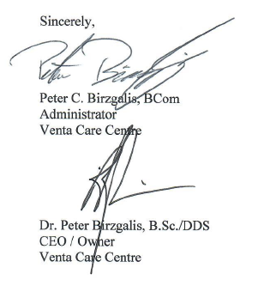
Sincerely,

ACCREDITATION

Accreditation Canada is an independent, not-for-profit organization that accredits more than 1,100 health care organizations and more than 6,000 community and facility-based sites.

Accreditation through the Qmentum Program is an ongoing process of assessing organizations, like Venta, to identify what is being done well and what needs to be improved. Qmentum standards guide quality improvement efforts to achieve safe and effective health services.

Venta works with Accreditation Canada to help improve quality, safety, and efficiency so that we can provide the best possible care and service to our residents and families. We recognize that Standards of Resident Care and Required Organizational Practices must be met to ensure that our Clients and Families have confidence in our services.

There are three levels an organization can achieve in terms of accreditation. They include being Accredited, Accredited with Commendation, and Accredited with Exemplary Standing. Venta Care Centre is Accredited with Exemplary Standing through Accreditation Canada, which is the highest level achievable. Venta has met all standards required for that certification.


Venta Care Centre is also regularly inspected by a number of other government standards and institutions including, Alberta Health & Wellness, Continuing Care Health Services Standards, Alberta Health Accommodation Standards, Environmental Public Health, and the Continuing Care Safety Association.

Results and certifications achieved are displayed in the display cabinet in the front foyer of the Facility, addressed in our facility newsletters, and posted on our website. Results can also be made available to you upon request.

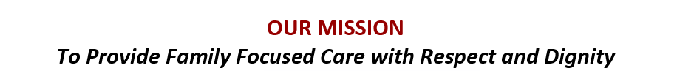

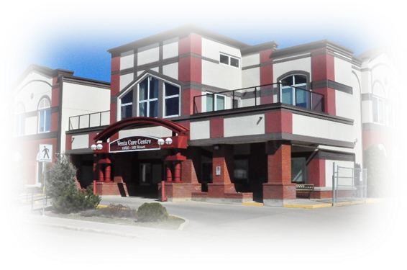



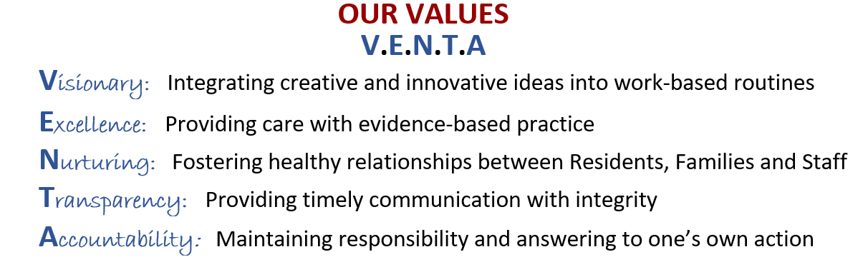

RESIDENT RIGHTS AND RESPONSIBILITIES

RESIDENT RIGHTS AND RESPONSIBILITIES

When people live communally there is often a need to discuss what is important to each person. Resident’s, Resident’s Families and Health Care Workers are expected to treat one another with respect and dignity and communicate openly.

Compromises must sometimes be made so that the choices of one person do not interfere with the rights of another person. Everyone has the right to a safe physical, emotional and psychological environment.

RESIDENTS RIGHTS:

- Be treated with compassion, courtesy, dignity, and respect
- To live in a comfortable, clean, and safe environment free of abuse and harassment
- Be provided safe, quality care within the resources available
- Have your beliefs, values, and preferences respected
- Have your privacy acknowledged and respected
- Have your confidentiality maintained in accordance with law
- Raise concerns, ask questions, participate in decision-making (on your own or through your legal representative) without fear of interference, coercion, or reprisal
- Participate in social and recreational activities of your choice
- Be able to access information about your rights, care, accommodation, and other information related to you personally

RESIDENTS RESPONSIBILITIES:

- Participate in keeping your surroundings safe
- Treat others, including other residents, staff, and visitors, with respect and in a courteous manner
- Respect the rights of staff and management to work in an environment that is free from harassment and abuse
- Respect the privacy of others and to keep their personal information confidential
- Ensuring your personal belongings follow the facility’s safety requirements
- Ensuring your actions do not interfere with other resident’s rights
- Participate in the planning of your own health care and treatment in collaboration with the health care professionals
- Pay all applicable fees, including room charges and applicable expenses
- Refrain from behaviour that is dangerous or threatening to yourself or others
- To comply with facility policies, procedures and rules defined in this handbook
- To follow Venta Care Centre’s ‘Resident Passes & Outings’ policy and procedures in the event you wish to leave the premises

ROOM AND ACCOMMODATION

Thank you for selecting Venta Care Centre as your place of residence and we welcome you to our 148 bed Continuing Care Centre. This Resident Handbook is intended to provide you with an overview of all the information you need to know as a resident or resident family member of Venta Care Centre

Continuing care provides individuals who have health conditions or disabilities with access to services they may need to maintain independence and enjoy quality living. Resident’s may benefit from long-term care for a variety of reasons including those with complex, unpredictable care needs better managed with 24-hour onsite nurses.

Venta Care Centre is a 24/7 secure, non-smoking, facility made up of approximately 72 private and 76 semi-private rooms divided between two floors. The second floor is divided into two units and houses a total of 55 residents. It includes a 27-bed unit for those residents with a higher level of dementia. The first floor is divided into three units and houses a total of 93 residents.

This handbook is intended to provide you an overview of Venta Care Centre and answer any questions that perhaps during the admission you forgot to ask. We also encourage you to visit our website at www.ventacarecentre.com for more information.

ACCOMMODATION RATES:

Alberta Health sets all accommodation rates for continuing care facilities in the province. These rates change from time to time and are based on the maximum amounts provided by Old Age Security, Guaranteed Income Supplement and Alberta Assured Income Program. Current accommodation rates are provided on page 31. The facility will provide a (ninety) 90-day notice period prior to rate increases in accommodation charges made by Alberta Health.

RESIDENT ROOMS:

Resident rooms are spacious and bright but do vary in size and configuration. Each room contains an adjustable hospital bed, bedside table, wardrobe, chest of drawers and chair. All rooms have an attached two or three-piece bathroom and are cable equipped.

Each room also contains a large bulletin board. One side of this bulletin board is for Venta Use. It will contain, among other information, the resident’s picture, transfer status, and diet type. Please do not remove any of this information or cover it with personal items as it is used to ensure clear and accurate direction to the staff caring for your loved one. You are welcome post any personal items on the Resident Use side.

Decisions about which unit you will be placed on, both when admitted and throughout your stay, will be based on the resident’s care needs and made by management. A private room may not be available to you on admission, but you have the option of being placed on a waitlist for a private room when it becomes available.

All common areas in the building are set to 22 degrees Celsius. Individual resident room temperatures are set to a comfortable range and if a resident or family member wishes to have their room temperature adjusted, they may have access to the room’s thermometer. Please contact the Maintenance Department at (780) 377-4544 from 8:00 a.m. to 4:00 p.m. Monday to Friday for assistance.
COURTYARDS:

Venta Care Centre takes pride in its beautiful courtyards, centrally placed to ensure resident safety. We ask that you accompany your loved one out to these courtyards and for their safety, remain with them while out of the building. The residents cannot be left alone as they could fall or injure themselves and they have no way to call for help. When the weather is nice, there is no better place to enjoy the outside. Tables and chairs are available in the courtyards, and we encourage you to utilize this area as much as possible.

RESIDENT BELONGINGS

We encourage residents to personalize their rooms to create a home-like environment by bringing in personal effects including pictures, decorations, and small pieces of furniture. That being said, it is important that staff are able to provide care to residents without being impeded by a resident’s belongings. Please notify management before bringing in furnishings such as chairs, bookshelf’s, large pictures, tables, lamps, etc. If a personal item affects a staff members ability to provide care or creates a hazard for residents, staff, or visitors, that item will not be permitted in the facility or need to be removed from the facility within a timeframe agreed upon by management. Venta will make every effort to contact you regarding the safety concern. Any pictures or other wall hangings you wish to place in room will need to be mounted by Venta Maintenance personnel.

When considering furnishings, please consider whether the item is water resistant and can be easily cleaned. Wood surfaces cannot be easily cleaned and should be avoided. If you wish to provide upholstered or wood furniture, it should be new (presented with a receipt of purchase) or certified bed bug free. Venta has secured a reduced price for inspection and treatment of upholstered furnishings for residents with a pest control company. If interested, you may call 780-371-9420. You will be required to present the inspection report as proof when bringing item into the facility.

All electrical items brought into the facility, including lamps, televisions, and radios must be inspected by our Maintenance Department. All electrical devices must have an affixed CSA sticker. If a device does not meet CSA standards, it will not be approved for use.

For resident safety please do not bring in chairs that rock or swivel, area rugs, heating pads, hot water bottles, magic pads or any sharp devices like scissors, metal nail files or breakable glass items.

Venta Care Centre is not responsible for the safety or security of any personal items brought into the facility.
For this reason, we recommend that valuable or irreplaceable items not be brought into the facility

HEARING AIDS:

The resident/official spokesperson/agent/trustee is responsible for resident’s hearing aid needs including providing hearing aids, the cost of replacing them, and making hearing aid appointments and arranging for transport to and from appointments. The cost for services must be paid directly and are not added to monthly invoices.

Venta Care Centre is not responsible for the loss, damage, or malfunction of resident hearing aids. We strongly recommend that all hearing aids be affixed to a holding pendant type support to allow for visual accessibility in the case of displacement or loss. There are still many ways hearing aids can go missing or be damaged and therefore we highly recommend you insure your hearing aids.

Venta Care Centre will, due to the vulnerability of our residents, attempt to assist in the protection against loss of the hearing aids, through provision of evening collection and storage at the Nursing Station and daily return to the resident in the morning.

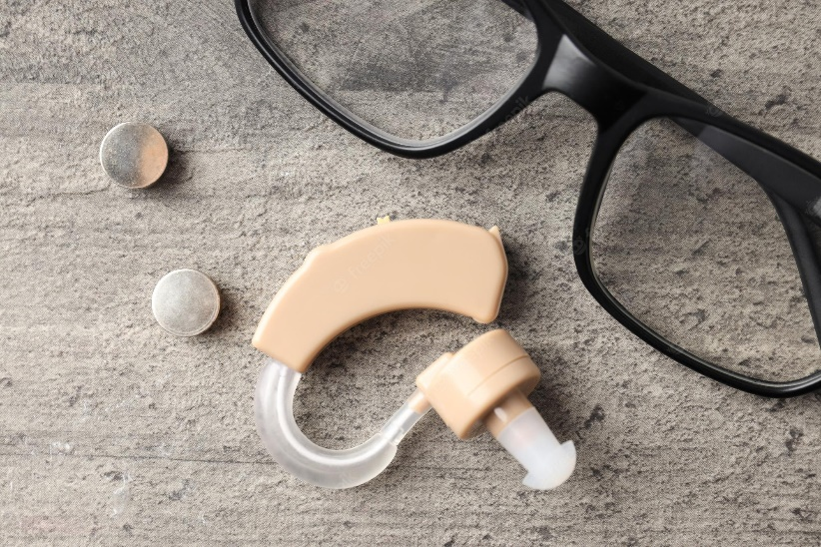

EYEGLASSES/ DENTURES:

The resident/official spokesperson/agent/trustee is responsible for resident vision care including the cost of eyewear or replacement and repair of eyewear and making appointments and arranging for transport to and from appointments. There are some reimbursements available through certain healthcare plans. The family is responsible to review the benefit plan they have with their care provider.

Venta Care Centre is not responsible for the loss or damage of resident eyeglasses or dentures. We strongly recommend that all glasses be affixed to a holding pendant type support to allow for visual accessibility in the case of displacement or loss.

We recommend that all hearing aids, eyeglasses, and dentures be marked or engraved with the resident’s name for easy identification

CLOTHING:

Resident clothing should be comfortable, easy to put on and easy to remove. To maintain a resident’s independence, they are encouraged to participate in dressing themselves whenever they are able. A resident’s choice of clothing will be respected.

All personal clothing brought into the facility must be washed and dry (placed in a dryer for at least 40 minutes), or brand new.

All clothing items will be heat-seal labelled with the resident’s name, by Laundry Services at Venta Care Centre, for a charge of $0.50 plus GST per item. Please provide the front desk (reception) with all items to be labelled at least 48 hours prior to the admission day to allow our staff adequate time to label all items.

Any clothing items brought in during the residents stay, after admission, must also be taken to the front desk (reception) so that a heat-sealed label can be applied. Venta Care Centre cannot assume responsibility for any unlabelled clothing. We recommend the family review on a regular basis what the resident has in their closet to identify any missing items or the need to replace seasonal clothing.

Suggested clothing list:

- 7 full sets of daytime clothing
- 7 undershirts/bras/slips/underwear (if appropriate)
- Nightwear (as required)
- 10 pairs of socks/stockings
- 3 cardigan-type sweaters
- 1 pair of slippers (closed heel with non-slip soles)
- 1 pair of comfortable walking shoes with non-slip soles (please avoid bringing Crocs or any backless, slip-on shoes or sandals)

Please note that clothing made of cotton, wool or rayon does not launder well in industrial washers and dryers. Instead, we recommend, choosing clothing made of nylon, polyester, and cotton blend whenever possible. Dry clean only clothes are the responsibility of the resident or family to clean and not recommended to be brought into the facility. Ironing and mending services are not provided.

Venta Care Centre is not responsible for any damages that may occur to clothing during washing or drying.

Additional clothing, including coats, scarves, boots, gloves, sunglasses, and hats, may be required for any outings a resident may go on.

PERSONAL CARE ITEMS:

The resident, spokesperson, agent, trustee is responsible for purchasing any personal care items the resident may need. Items include, but are not limited to:

- Soap/ body wash (unscented / non-floral)
- Shampoo/ conditioner
- Toothbrush or denture brush and toothpaste
- Comb/ brush
- Deodorant
- Kleenex
- Sunscreen and body/ facial lotions
- Makeup (if appropriate)
- Rechargeable razor (must be clearly marked)

Note: Talcum powder and denture pastes (unless directed by the dental department), soaks, tablets, and mouth rinses are also prohibited.

Some residents, staff, and volunteers have allergies and medial conditions that are triggered by strong scents. We therefore ask that the use of scented products be kept to a minimum.

All personal care items must be clearly labeled with the resident’s name using a permanent marker or something similar and be provided in the original manufacturer’s container.

Resident assigned toolkits are provided for the storage of resident personal care items in rooms with shared bathrooms (semi-privates).

TUCK CART:

For the convenience of our residents, Venta Care Centre has a Tuck Cart that goes from unit to unit for anyone wishing to purchase snacks, toiletries, and other personal care items. All purchases are applied to the billing invoice for the month. If you do not wish your family member to purchase items from the tuck cart, please contact the Recreation Department at 780-377-4412.

MOBILITY SUPPORTS AND DEVICES:

Walkers, wheelchairs, and other mobility devices are either loaned out by the facility or purchased / loaned through an outside vendor by the resident, spokesperson, agent, or trustee. Alberta Aids to Daily Living (AADL) provincial program assists in the supply of basic medical equipment required. AADL operates on a cost-share basis and residents may be eligible for assistance. Depending on the resident’s income, there may be costs involved. If equipment such as a wheelchair is required, our Occupational Therapy department will make a referral. The facility has a wheelchair washing machine used to clean resident mobility devices on a scheduled and as needed basis.

INCONTINENT PRODUCTS:

Venta Care Centre provides incontinent briefs, pads/liners, and mesh panties. Pull up briefs are not included and must be provided by the resident/official spokesperson/agent/trustee if preferred. Please be aware that if incontinent briefs are used, they should not be confused with store bought products.

RESIDENT COMFORT FUND/MONEY:

Your family member will have little need for any money as everything is covered with their monthly fee. We request that if you choose to leave money with your loved one, that you leave no more than $20.00 at any one time. Unfortunately, if the money is lost it is very hard to retrieve or find and we cannot take responsibility for its loss. We discourage expensive valuable items or money to be left with the resident. A discussion should occur with the Social Worker regarding containment of credit and debit cards where residents are their own decision maker.

Venta Care Centre does provide a ‘Resident Comfort Fund’ for its residents. Each resident can contact the front desk/ reception to receive small amounts of cash ($5.00 to $20.00) which will be added to the monthly invoice to be paid at that time. There is no need to store money in resident rooms.

Accounts regulated by Trustees will be requested for the purpose of purchasing items the resident needs. Staff will complete the purchases when monies are delivered and receipts for all purchases are provided with each transaction. Any questions regarding these funds may be discussed with the Social Worker for clarification of needs.

ADMISSION PROCESS

Upon admission, nursing staff will verify the residents care needs which are used to develop an individualized Care Plan. Family members are encouraged to be present during the admission process because they can play a vital role in easing a resident into their new home. By sharing vital knowledge, and information about the resident’s personal life, history, and daily routines you can better assist staff in caring for the resident.

ATTENDING PHYSICIAN:

On admission the resident is assigned an attending physician who will be responsible for their care. The Alberta Health Services minimum standard for continuing care physician visit is quarterly, however many of our physicians visit more frequently. Physicians work closely with the nursing staff and respond when the nursing staff or family request and require additional assessment or visits. After hours and on weekends the physicians rotate on an on-call schedule to deal with emergency issues.

NURSING:

Venta Care Centre is staffed around the clock with Registered Nurses, Licensed Practical Nurses and Health Care Aides. Nursing is managed by a DON, Resident Floor/ Care Manager or Charge RN who ensures that daily individualized quality care is received by each resident and that all services conform to facility policies and standards, guiding principles, ethics, values, and regulations.

REGISTERED DIETITIAN:

Our Registered Dietitian will assess the residents’ dietary needs including texture, fluid consistency and food allergies and preferences. Therapeutic diets are available according to resident’s needs.

OCCUPATIONAL THERAPY:

Our Occupational Therapy department will assess and provide interventions to each resident in terms of their positioning, interactions skills, functional independence in self-care activities. Residents will be assessed for placement into activities/ programs that best meet their individual physical, cognitive, social, and emotional needs, and abilities as well as preferences and choices.

RECREATION THERAPY:

Our Recreational Therapy department designs activities to improve or maintain the social, cognitive, and physical status of residents. Recreation therapy programs expand resident engagement in meaningful activities. A monthly recreation schedule of programs and activities are available on each unit and on Venta’s website.

The Venta Care Centre ‘Resident Council Society’ has its own wheelchair accessible bus which is used to transport resident’s to places within the community such as malls, museums, parks, theatres, etc.

SOCIAL WORKER:

The Registered Social Worker is available to provide emotional support, counselling services and practical assistance to residents and their families.

The Social Worker will review the resident’s social and family history, review resident’s Personal Directives and Enduring Power of Attorneys and discusses and completes Goals of Care with Nursing and Medical Staff.

The Social Worker can assist resident and/or family/ guardian/ responsible spokesperson/ legal representative with Old Age Security, Canada Pension Plan, Guaranteed Income Supplement, Alberta Seniors Benefit, Involuntary Separation applications, referrals to the Office of the Public Guardian and/or Office of the Public Trustee and other Community Agencies as needed.

FOOD / NUTRITION SERVICES

Three nutritional meals are provided daily, along with snacks. They are prepared in-house by a Red Seal chef and are transported to the food holding areas on each unit. The food is served from the steam tables to the resident by the Health Care Aide (HCA). The quick delivery of the food along with skillful preparation contributes to high quality hot meals. Fluid and solid intake is tracked daily to monitor resident consumption.

MENUS:

Seasonal menus are planned to ensure all meals, fluids and snacks meet Canada’s Food Guidelines. Nutrition and food services follows provincial standards for food handling and hygiene and current food establishment permits are maintained.
Daily menus are posted in each dining room. Residents are offered two options for lunch and dinner entrée.

DINNING ROOMS / MEAL SERVICE:

You will be introduced to your Dining Room soon after admission. Each resident has a place assigned to them in the dining room. Information on resident’s food consistency, fluid level, food likes, dislikes, restrictions, and allergies are provided in each dining room.

If a resident requires tray service, it will be delivered after all residents in the dining room have been served.


Family members / visitors, who wish to join their loved one in the dining room, have the option of purchasing meal tickets at Reception (depending on CMOH Orders/ Facility Policy on masking). This will need to be arranged in advance to ensure there is enough food sent to the Dining Rooms. Please contact Reception Monday to Friday 9:00 am to 5:00 pm if you wish to purchase a meal ticket or would like to join your loved one in the dining room. We have designated seating areas for visitors in the dining room that will adequality provide you and all other residents privacy.

Dining Times:

Breakfast: 8:45 am – 9:00 am
Lunch: 12:00 pm
Dinner: 4:45 pm

(Dining times may vary)

“One cannot think well, love well, and sleep well if one has not dined well”
- Virginia Woolf -

SNACKS AND BEVERAGES:

Snacks and beverages are prepared and delivered to the residents by the Health Care Aides.

Snack Times:

AM Snack: 10:30 am – 11:00 am
PM Snack: 1:30 pm – 3:00 pm and 7:30 pm – 8:00 pm

Water and extra fluids are offered and frequently circulated especially during the warmer temperature days.



PERSONAL FRIDGES:

To ensure the safety and wellbeing of our Residents, Personal Fridges are not allowed in Resident Rooms at Venta Care Centre.

BRINGING IN FOOD OR ALCOHOL:

Due to the possibility of specific diet restrictions, it is important that if you wish to bring in food for the resident that you check with the nursing station first. Only small portions of food that may be consumed in one visit may be brought in. Inadequate storage of food promotes insect infestations, therefore please take home all leftovers.

To avoid choking or an unfortunate accident please do not share food with other residents.

Residents cannot store food in the designated Dining Room Fridge or Nourishment Centre’s within Venta Care Centre. This is in accordance with the Long-Term Care Accommodation Standards established by Alberta Health & Wellness. For residents with special dietary needs or when comfort foods are requested, families can contact our Dietary Technician for storage arrangement. Families, visitors, and residents are restricted access from Kitchen Serveries and Nourishment Centre’s.

Alcoholic beverages may not be stored in resident rooms. When bringing alcoholic beverages onto Venta Care Centre premises, please deliver to the resident’s Nursing Station. All alcoholic beverages permitted by the resident’s Physician will be administered by the nurse. For resident’s wishing to participate in the Social Alcohol Program there must be a separate consent form signed by the physician and the official spokesperson/agent/trustee.

VISITATION

Venta Care Centre encourages resident family and friends to visit their loved one as often as they like, as this is a good way to stay connected.

Family and friends are encouraged to participate in recreational programs, outings, and special events. For information on scheduled activities, please refer to the Recreational Calendar, on Venta Care Centre’s website.

VISITATION HOURS:

Venta Care Centre encourages visitation between the hours of 10:00 am and 4:00 pm, seven (7) days a week. Visitation hours end at 8:00 pm (special consideration for extended visitation offered on a case-by-case basis).

Please note that if the site is on outbreak, restrictions on visitation may apply as per direction of the Medical Officer of Health.

Visitors must understand that they are entering the home of many individuals. Visitors are asked to respect the privacy of all residents and the need for a quiet and calm environment. Children of all ages are welcome, but we ask that young children be supervised appropriately.

FACILITY ACCESS:

Venta Care Centre has one main entrance that is secured / monitored 24/7. Facility access is available through key fob (see Reception for application form) or by pressing the front buzzer button.

If a visitor feels ill or develops any symptoms while on site, they are expected to notify the unit nurse and leave the facility immediately. Alternatives to in-person visits offered include video calls (via Skype, FaceTime), telephone calls, and window visits. To make arrangements for alternative visitation you may contact a member of the Recreation Department by phone at 780-377-4412 or by email at recreation@ventacarecentre.com for assistance.

Please note that there are restricted areas within the facility that are either locked or identified with appropriate signage. These areas are designated for staff only.

All visitors are required to comply with Venta Care Centre’s polices, procedures, and rules as set out in this handbook. Non-compliance with any of these polices, procedures or rules can result in visitation restrictions, up to and including total restriction from visitation, as determined by management.

VISITOR SIGN IN/OUT:

Visitor Sign-in / out sheets are located at the main entrance. All visitors entering and leaving the building are required to sign in and out. This is an important safety measure in place to ensure all visitors are accounted for in case of a fire or other emergency.

For the safety of residents who may not be able to leave the facility without accompaniment, we request that you ensure you look behind you when exiting the building. If you are accompanying a resident on an outing, please ensure you inform the RN/LPN at the resident’s Nursing Station (as per Outing Process) and sign them out.

PARKING:

Visitor parking is available streetside in front of the building. Please remember that you must not park in front of the fire hydrant located in this area. Please refrain from parking in front of our neighbors’ homes driveways. Parking or leaving vehicles unattended in the front driveway at the main entrance to the facility is prohibited to allow for emergency service access.

Wheelchair accessible parking stalls are in front of the facility. A ramp is provided to allow wheelchair access from the street to the heated driveway.

RESIDENT AND FAMILY LOUNGES:

There are resident and family lounge areas on each unit for residents and their loved ones to visit. These areas provide residents and families a nice area socialize outside of the resident’s room. The spaces provide seating and come equipped with television sets. Visitors utilizing these lounge areas are asked to dispose of any food packages or cups before leaving.


PETS:

Family and friends are welcome to bring their pets to visit; however, the pets must be registered through the ‘Venta Care Pet Program’ which includes providing proof of current vaccination and behavior control.

Pet owners and handlers are responsible for the behavior of the animal, and pets are required to remain leashed while in the facility.

Only one pet at a time is permitted in the facility. Appointments must be arranged with Reception.

VISITOR SAFETY

FIRST AID STATION:

Should the need arise, Venta’s First Aid Station is located on the 1000 Nursing Station. It is equipped with an Emergency First Aid Kit, and nursing staff to provide first aid services as needed until EMS arrives (if necessary).

FIRE DRILLS:

Fire control expertise is maintained by holding regular fire drills. Upon activation of the fire alarm, bells will ring, and fire /smoke doors will close automatically. In the event of a fire or fire drill, visitors must follow all instructions provided by the care team.

EVACUATION MAPS:

Evacuation maps are located at all elevators, stairwells and exits. They indicate the closest route in the event of a required evacuation.

SMOKE FREE ENVIRONMENT:

Venta Care Centre is a smoke-free facility. This means smoking is not allowed inside or outside of Venta Care Centre property. Visitors must be on or beyond the main sidewalk to smoke.

SIGNAGE:

For your safety, please observe all floor-washing signs, as floors may be slippery when wet.

SECURITY CAMERAS:

There are areas of Venta Care Centre under video and audio surveillance (signage publicly posted) for facility safety. Video surveillance / electronic monitoring is not permitted where residents have a reasonable expectation of privacy such as the resident’s bedroom or bathroom.

WORKPLACE VIOLENCE & HARASSMENT:

Venta is committed to maintaining a healthy and abuse-free environment. Violence, harassment, or discrimination committed by any member of the public will not be tolerated.

Venta has a workplace violence and harassment prevention plan in place to protect all who visit, live, or work within the facility.

Please use caution when approaching residents during your visit. Some may exhibit unexpected behaviours.

HAZARD REPORTING:

Venta Care Centre welcomes all visitors or family members to report any potential hazards identified. This may be reported to any Venta Care Centre Staff.

INFECTION PREVENTION & CONTROL

HAND HYGIENE:

Hand washing is the most effective means of preventing the spread of infection. Alcohol-based hand sanitizers are located throughout the facility including the front entrance, dining rooms, and halls. Staff, visitors, and residents are provided information on the importance of hand hygiene and when and how to wash hands.

Hand washing reviews are completed regularly to identify hand hygiene compliance and to allow for ongoing improvement of hand hygiene practice in the facility.



PERSONAL PROTECTIVE EQUIPMENT (PPE):

All staff, visitors, and residents required to wear a mask must perform hand hygiene prior to putting on, and after removing or touching their mask to reduce the risk of self-contamination.

Resident rooms under isolation will be clearly marked identifying what protective equipment, which may include gloves, mask, and gown, are required prior to entry. For visitor safety, staff will provide visitors clear instructions on how to properly wear and remove PPE when required in the building.

VACCINES:

Vaccines are a critical way to limit the spread of respiratory viruses like influenza and COVID-19. They are effective and safe for protecting the health of residents, staff, and visitors.

Residents living in a communal living environment are more likely to be infected by viruses due to their underlying medical conditions and other factors. We therefore highly recommend all residents, staff, and visitors regularly get vaccinated.

Venta Care Centre has a vaccine program in place to promote and administer influenza and COVID-19 vaccines (with consent) to all residents and staff each year. The Pneumococcal Vaccine is also administered to all new residents on admission if they have not already received one in the past.

OUTBREAK PROTOCOLS:

If the facility experiences an Outbreak, resident’s and families will be notified and visitor restrictions may be implemented as per the direction of the Medical Officer of Health.

Management must adhere to all measures provided by Alberta Public Health in alignment with Alberta Health Services Outbreak Prevention and Control Guidelines.

Residents affected or on affected units will be contacted directly by a member of the nursing tea. Resident and Family Newsletters, posted on Venta’s website, will also provide regular, current outbreak status updates.

For more information you may also visit Alberta Health Services Website www.albertahealthservices.ca or call HEALTH LINK at 780-408-5465 for health-related questions regarding Infection Control.

OUTINGS

We encourage residents and their families to enjoy outings together. Family members or designated person(s) who wish to take their loved one on an outing, must comply with Venta Care Centre’s outing procedures which include the completion of an ‘Application Request for Resident Pass for Outings’ form, communication with the unit nurse, and signing resident out at Nursing Station.

Generally, there are no restrictions on social outings. For extended leaves please provide the facility at least seven days’ notice so that medications can be prepared ahead of time.

The family member or designated person(s) taking takes full responsibility of the resident they are taking out and must ensure they receive all medications provided at the time(s) indicated by nursing staff. Emergency services should be contacted for any medical emergencies the resident may experience while out of the facility.

FACILITY LEAVE:

Continuing Care Centre residents are entitled to a maximum of 50 days facility leave per fiscal year. This includes leave due to hospitalization or other.

During these 50 days, the resident will be charged the full accommodation rate, as per government standard. Resident’s requiring an extension beyond 50 days require approval from the facility in consultation with Alberta Health Services, Long Term Care.

TRANSPORTATION AND ACCOMPANIMENT:

Options for transport are car, taxi, DATS (applications take approximately one month to process), wheelchair taxi, inter-hospital transport and ambulance (in case of emergency). The resident’s family member or friend that accompanies residents on an outing or out of facility appointment are encouraged to do so by use of their own vehicle when possible. For medical appointments ordered by your Physician or of an urgent nature, transportation via ambulance or inter-hospital transport will be arranged.

We do prefer family accompany the resident on out of facility appointments. If a family member isn’t available, the resident/ primary contact may choose an external service provider who will designate a qualified person to accompany resident to and from appointments at a charge.

GIFTS AND GRATUITIES
Residents or family members may wish to thank employees by offering gifts of appreciation. Employees at Venta Care Centre may only accept small acts of kindness or tokens of thanks such as candy, cakes, cookies, etc. Employees are prohibited from accepting cash, gifts, jewelry, or other items like this, from residents or family members for services provided. Employee shall not become involved in residents’ financial affairs, including Power of Attorney, Wills, Estates, or non-financial affairs including Personal Directives and Guardianship. Such requests from residents will be referred to the Facility Social Worker.

RESIDENT SAFETY

FALLS:

Falls are a concern for our residents. Our staff cannot prevent every fall; however, they do work with residents to minimize the risk of falls and/or injuries form falls. Residents can help by wearing appropriate footwear, participating in exercise programs, and following safety strategies.

Venta’s ‘Catch a Falling Apple’ Falling Prevention Program is a collaborative effort where all members of the health care team along with the resident, and their family play an important role in preventing falls and injuries from falls.

Injury prevention equipment available at Venta Care Centre includes fall mats, hip protectors, high/low beds, visual aids for high-risk residents (falling apple symbol), wheelchair alarms, bed alarms, emergency call system in the bathroom of resident’s room, and staff pagers.

We endeavor to implement Best Practice Fall Prevention measures based on resident’s fall history, diagnosis, and other potential factors.

CALL BELL OR PENDANT:

Residents will have access to a call bell or if needed pendent in each room. Pull cords are also located in each bathroom.

We have a monitoring system that identifies the time it takes to respond to call bells. Response time varies depending on the immediate care needs on the unit.

MANAGED RISK AGREEMENTS:

Residents or alternate decision makers have the right to choose options that may have some degree of risk to the resident. These choices may not put other residents, staff, or Venta Care Centre at risk and must be in keeping with current legislation.

A Managed Risk Agreement will be completed to communicate the risks associated with a resident or alternate decision maker’s choice. It will outline the potential negative health care outcomes that may arise from that risk, care team recommendations, and strategies to manage risk to resident.

BATHING:

To promote resident hygiene, wellbeing and quality of life, all residents shall receive a tub bath, a shower, or a bed bath at least twice weekly and as needed.

To ensure the safety and comfort of our residents, staff are fully trained and annually review the safe bathing best practices including the applicable Alberta Health Services Legislation codes and standards to ensure ongoing competency. Water temperature will be checked before the resident enters the tub or shower and will be kept in a safe range, between 38°C and 43°C.

Venta Care Centre has a water temperature control device in place at the tub / shower outlets that controls the maximum allowable water temperature to be 43°C. Water temperatures are also checked every morning before any bathing begins for the day.

RESTRAINTS:

We comply with the Alberta Health Services Least Restraint Standards and Guidelines. To allow the greatest independence possible and the best quality of life for our residents, we look at the least restraint necessary to keep them safe. Restraints can be either mechanical – a device or piece of equipment used to restrict a resident’s movement (i.e., seatbelt, lap tray), or pharmacological – medications like antipsychotics used to control behaviors, actions, or freedom of movement.

IDENTIFICATION BRACELETS & PHOTOS:

An identification bracelet with the resident’s name is placed on the resident at the time of admission and a photo identifier of the resident is taken (on the day of admission) and placed in the Health Care Record, on our Electronic Medication Administration Record, and posted in the resident’s room. This is a mandatory process that assists in safe care, please do not remove these pictures at any time or for any reason.

NO ABUSE TOLERANCE POLICY:

Venta Care Centre is committed to ensuring a healthy and abuse-free environment. We have a duty to protect residents from abuse and comply fully with the Protection for Persons in Care (PPIC) Act. Abuse by or against any employee, medical staff, contractor, volunteer, visitor, or resident is considered intolerable and unacceptable conduct.

All allegations of abuse will be investigated by management and dealt with in accordance with Venta Care Centre policy/ procedure and relevant legislation.

COMMUNICATION & PROCESSES

CARE CONFERENCES:

There will be an expected adjustment time for you and your family to get to know and become comfortable with your new surroundings, your room, the staff, and the programs. During this time, we are also getting to know you better. As vital members of the care team you are provided the opportunity to participate in the development and review of the resident’s Care Plan during a Care Conference.

We will be requesting the resident and/or family/ guardian/ responsible spokesperson/ legal representative, and/or any other individual(s) of their choosing to attend a Care Conference within the first three (3) months of admission and annually thereafter.

Additional conferences may be held at any time if there are a significant number of concerns or changes that require a review and/or resolution.

The multidisciplinary team that takes part in a care conference includes the resident’s attending physician, nursing staff (Resident Floor Manager / Care Manager), Occupational Therapy, Dietitian, Pharmacy, Social Worker, and others as required. You will find these conferences helpful as they allow you to ask questions and provide input to the entire team that provides care to your loved one. Residents are not expected to attend these conferences, but their input will be requested prior to the date of the conference.

The Physician is only required to attend the admission Care Conference. A Physician may attend an annual Care Conference when needed and/or at the request of Venta Care Centre.

Notification of Care Conferences will be made in advance. Attendance is recommended as it will provide you better understanding of the care planning process and facilitate trust and a working relationship as we attempt to provide the best possible quality care and services. You may request a Care Conference with the full team present if you feel this is necessary.

Care Conferences may be conducted via telephone under certain circumstances as determined by the facility.

If the resident and/or family/guardian/responsible spokesperson/legal representative is unable or unwilling to attend a Care Conference and participate in resident care planning, it will be documented as such in the resident’s Care Plan. The resident’s Care Plan will be provided to the resident and/or the resident’s legal representative at any time.

NEWSLETTERS:

Venta Care Centre publishes a quarterly Health and Safety newsletter and provides regular Resident and Family Updates on our website. This is our way of keeping you informed of health and safety information, facility changes, upcoming events, and requests for your input.

RESIDENT AND FAMILY COUNCIL:

The Resident and Family Councils Act requires all operators to support residents in their home by creating a resident and family council.

Resident, Family Engagement Council meetings provide regular opportunities for staff to inform residents about changes in the facility and/or services. The council also provides a forum for residents to discuss ways to make their lives and the lives of other residents better. It allows residents an avenue to share their thoughts with staff on their accommodations, health services, future fundraising programs, recreation activities, and menu options among other things.

Upon admission, every resident to Venta Care Centre automatically becomes a member of the ‘Resident’s Council Society’. No membership fee or application fee is necessary. With the resident’s consent, family members are also welcome and encouraged to attend these meetings.

Meetings are held monthly (or more frequently if required) and chaired by a facility representative. Elections are held once a year to fill positions in the council which includes, the President, Vice President, Treasurer, and Secretary.

POLICIES AND PROCEDURES:

Venta Care Centre’s policies and procedures are available for viewing by all resident and/or family/ guardian/ responsible spokesperson/ legal representative, who have made an appointment during regular business hours. Appointments can be booked with reception by calling (780) 377-4400.

RESIDENT SAFETY DISCLOSURE:

Venta Care Centre ensures all care is taken by all staff to protect each resident. Resident safety incidents or events, including but not limited to, falls, choking episodes, and adverse reactions to medications, will be disclosed to the resident’s primary contact. Our protocol is to address any urgent care needs, inform the resident’s physician and on-call manager, and notify the resident’s primary contact of what occurred, how it occurred and what immediate steps or actions were taken.

SERVICES

FRONT DESK / RECEPTION:

The front desk / reception staff are the first contact for all families, visitors, friends, or responsible parties. Please feel free to stop in with your questions. The reception staff will be happy to answer any of your questions or refer you to the appropriate person to address them.

Any questions you may have about room accommodation charges, and/or other personal service charges – including but not limited to, hairdressing, foot care services, dental, laundry, and telephone – can be addressed with Reception staff.

As per the current regional room rate, Venta Care Centre charges a per day fee. In the event the resident no longer resides at Venta due to permanent discharge, the days paid for in advance from the date of discharge will be calculated and refunded, less any outstanding charges on the account.

Monthly invoices are distributed to the resident or person responsible for the finances on the first (1st) business day of each month. Statements apply to the current month for room accommodations, laundry, telephone, and television expenses. All additional personal service expenses (i.e., foot care services, hair salon services, etc.) are applied to the previous month. Payments are due by the tenth (10th) of each month.

Meal tickets, clothing labels, and nightwear apparel may also be purchased at reception. See price list on page 31 for more information.

Please note that you will be notified in advance of any price increases or termination of personal services provided.

Reception Desk hours are 9:00 am to 5:00 pm seven days a week.

FOOT CARE:

Nurses specializing in foot care provide foot care services monthly on site in the privacy of the resident’s room. Services include toenail cutting, trimming, and filing, reducing/ removing corns, calluses, and fissures, completing foot assessments and evaluations to detect foot and nail deformities that include diabetic feet. The cost, with exception of $15.00 for those over 65 years old and $25.00 for those under 65 years old is covered by Alberta Health. Foot care fee is applied to the resident’s next monthly invoice.

PHARMACY:

Medications are ordered by the resident’s attending physician at Venta Care Centre and are provided by our partnering pharmacy, on a weekly basis.

All medications are safely stored in medication rooms/ carts and dispensed by the LPN or RN or qualified HCA on the unit. Medications required for residents going out on pass will be dispensed to family accompanying resident.
DENTAL:

Venta Care Centre is equipped with a fully functional dental clinic onsite. We offer residents dental services by our team of qualified professionals. The resident/official spokesperson/agent/trustee is responsible for any costs associated with any dental services required.

An Oral Assessment will be completed upon admission (and more often at the request of nursing). Any additional dental work made by the resident and family should be communicated to the RN/LPN on duty.

The resident and/or family/ guardian/ responsible spokesperson/ legal representative will be contacted prior to the provision of any dental services.

OPTICAL AND HEARING AID:

Arrangements, including transportation and accompaniment, to/ from optical and hearing aid appointments, and the cost of associated appointments are the responsibility of resident and/or family/ guardian/ responsible spokesperson/ legal representative.

LABORATORY SERVICES:

Venta Care Centre utilizes DynaLIFE for laboratory services on site. There is regular, lab collection days each week. Lab results are reviewed by the resident’s attending physician and shared on a need-to-know basis.

X-RAY SERVICES:

Diagnostic imaging x-ray services for residents on site by qualified radiologists through Canada Mobile X-Ray.

HAIR SALON / BARBER:

Hair dressing services are provided for males and female residents regularly by a licensed hairdresser. Appointments are made at the front desk/reception.

Resident and/or family/ guardian/ responsible spokesperson/ legal representative is responsible for payment for services. This cost is applied to the next monthly invoice for the month. See price list on page 31 for more information.

RESIDENT TELEPHONE:

If the resident requests to have a private telephone in their room, it is the responsibility of the resident / official spokesperson/agent/trustee to contact Reception for line availability. The facility will contact and facilitate telephone hook up. Telephone services fees on page 31.

A telephone must be provided by the resident / official spokesperson/agent/trustee. All long-distance charges are applied to the monthly bill. Once telephone has been hooked up, the telephone number will be provided.

CABLE TELEVISION:

All resident rooms in the facility are equipped with cable. Cable services are a non-optional charge. TV and cable in the resident room is not included in the monthly accommodation fee.

On admission, please let the front desk/ reception know when you intend to bring in a TV and it will be hooked up to the cable by Venta Maintenance staff. Cable services fees on page 31.

NEWSPAPER:

If a resident requests to receive a newspaper subscription, it is the responsibility of the resident / official spokesperson/agent/trustee to arrange delivery to the Venta Care Centre by calling the newspaper provider. The resident will be billed directly by the provider of their choice.

MAIL/ DELIVERIES:

Mail, including personal correspondence and greeting cards, and other deliveries including flowers, and parcels/ packages, are delivered directly to the resident’s room by Venta Care Centre staff. Any outgoing mail may be dropped off at the front office/ reception desk.

Government or legal mail should be sent to the resident’s official spokesperson/agent/trustee mailing address and not Venta Care Centre.

LAUNDRY SERVICES:

On-site laundry service is available for all personal clothing at a daily charge of $2.50 plus GST per day and is added to the monthly invoice.

Personal clothing may be taken home by the family if this is your choice. If so, a basket must be provided by the resident /official spokesperson/agent/trustee for the room. Signage will be placed in the resident’s room to indicate to the staff that personal laundry is done by the family.

Venta Care Centre has a coin operated washing machine and dryer in the Venta Manor for residents who wish to wash their own laundry, at a cost of $2.00/load. Laundry soap and softener must be provided by the resident. Residents are not permitted to enter Venta Manor unless accompanied by a family member.

HOUSEKEEPING SERVICES:

In-house housekeeping staff clean and tidy each resident room daily. They replenish supplies as needed and change bed linens a minimum of once a week or more frequently as needed.

Fragile articles in resident rooms will not be cleaned or dusted by housekeeping staff. These items are discouraged from being brought into the facility and are not the responsibility of Venta Care Centre if damaged.

MAINTENANCE SERVICES:

Maintenance staff are available to provide routine and specialized maintenance services in the facility and on the grounds. Maintenance is available 24 hours a day for any concerns and oversees facility security, fire and safety, equipment maintenance / repair and facility air temperature.

VOLUNTEERS:

Volunteers are a valuable addition of our team. Venta Care Centre offers a wide variety of experience for volunteers who may assist staff in several different areas. Volunteers may work under the supervision of professionals in the Recreation, Hair Services, and Food Services department.

Venta Care Centre welcomes any family members and friends who wish to volunteer. As a volunteer you are honored each year with a special ‘Volunteer Appreciation Banquet’.

Please contact the Recreation Department at 780-377-4412 if you are interested in registering as a volunteer.


PASTORAL CARE SERVICES:

Church Services are provided by volunteer Priests, Ministers, and Chaplains. Services are scheduled by the Recreation Department. Residents are informed of scheduled Pastoral Care Services in the ‘Monthly Resident Recreation Calendar’ located throughout the facility.

DISCHARGE AND TERMINATION

Personal items must be removed within 48 hours from the date of discharge. Items that remain in the room after 48 hours will be packed by Venta Care Centre for a fee of $50.00 and a storage fee of $10.00 per day will apply. An available option is to donate your loved one’s items (furniture, clothing) to the non-profit Resident Council who will distribute items to residents that may need assistance.

FEEDBACK

Venta Care Centre is committed to providing high-quality care to those we serve in a safe and respectful manner. In the event you or your family member’s experience does not meet your expectations, you have the right to voice your concerns. Venta Care Centre has a policy and procedure in place to facilitate successful resolution of concerns or complaints expressed by residents, families, or visitors. We will work with you to find a mutually agreeable solution to resolve any concerns you may have as quickly as possible.

As a first step we encourage you to speak directly to the RN/LPN or Resident Floor Manager on duty who will make every attempt to resolve your concern.

If your concern cannot be resolved at this level, we ask that you communicate your concern in writing via a ‘Complaint/ Concerns’ form or verbally to a member of the management team who will record your concern on this form. All reported concerns or complaints will be addressed within five (5) business days.

If you or your family have a question about the resolution of your concern or fairness of how your concern was handled, you may contact our Facility Administrator at (780) 377-4542

If you are not satisfied with the Facility’s resolution, you may refer to an external agency, that includes:

Continuing Care Licensing Office (Concerns about accommodation or health services received):
Phone: 1-888-357-9339, option 3 Email: cclo@gov.ab.ca
Alberta Ombudsman Office: (780) 427-2756
Alberta Health Services Community Care Health Link: (780) 408-5465
Health Facilities Review Committee: (780) 427-4924
Protection For Persons in Care (Legislated in Alberta to protect adults in care facilities from intentional abuse that will result in an external investigation of the circumstances): 1-888-357-9339

If you have any feedback including comments, thank you’ s, suggestions, or ideas that may benefit Venta Care Centre, we encourage you to submit your feedback in writing or on the feedback portal on our website at: https://www.ventacarecentre.com/visitor-info/feedback/

Venta Care Centre also conducts regular family and resident Satisfaction Surveys. You will be notified when these surveys begin. Your feedback is valuable as we use it for quality assurance and improvement initiatives.

ETHICS

All of us are at times faced with ethical dilemmas. An ethical issue may present itself out of our wish to do the right thing. Ethics are intertwined with our beliefs, goals, cultural values, and religious ideologies.

Venta Care Centre is committed to responding to clinical or nonclinical ethical dilemmas with integrity, dignity, and respect to all parties involved. Residents and families should always feel free to bring forward any ethical dilemmas that may arise. Venta Care Centre uses an Ethical Framework congruent with its Mission, Vision and Value statements and person-centered care model.

This framework considers the impact an ethical dilemma may have on all parties involved. An external Ethicist – a professional with an advanced clinical degree who has specialized training in ethics and experience with ethical issues – may be involved in the ethical decision-making process.

CLINICAL ETHICAL DILEMMAS:

Ethical issues can arise when care or treatment of an individual is provided. It is the duty of all healthcare professionals to identify and address any ethical issues while providing care and treatment for a resident. Examples of clinical ethical dilemmas include:
- A difference of opinion between a physician and family member with regards to medical interventions.
- There may be conflict between family members as to who is able to make medical decisions when legal documents are not in place.
- The resident may desire a diet that is not in keeping with clinical advice or medical assessment.

VENTA CARE CENTRE PROGRAMS AND SERVICES

Venta Care Centre (VCC) offers a home-like environment where our mission is to ‘Provide Family focused Care with Respect and Dignity’. Each resident is a member of our family with unique strengths and needs.

Our professional nursing staff composed of Registered Nurses, Registered Psychiatric Nurses, Licensed Practical Nurses, and Health Care Aides take great pride in the excellent 24-hour care that they provide to our residents with kindness and compassion.

VCC CARE AND SERVICES INCLUDE:
- Registered Nurses, Licensed Practical Nurses, Nurse Practitioner and Health Care Aides onsite
- Pharmacy Services
- Oxygen Therapy
- Hydration (Clysis) Therapy
- Regular Physician Visits – per Government Standard
- Admission and Annual Multidisciplinary Care Conferences
- Assistance with scheduling and booking transportation to/from physician ordered medical appointments
- Foot Care Services onsite
- Laboratory Services onsite
- Mobile X-Ray Services onsite
- Recreation Services
  - Church Services (some denominations)
- Dental Clinic on site – Dental and Denturist Services
- Dietitian and Food Services – Red Seal Chef & Seasonal menus
  - Monitoring of resident hydration
- Social Worker
- Occupational Therapy
- Hair Salon onsite
- Personal Laundry Service (optional)
- Incontinent products
- Locked Secured Facility
- TV Lounge Areas on each Unit
- Semi-private and private rooms
  - Cable access in each room
  - Optional landline phone hookup in each room
- Mobility supports and devices through AADL
- Pendant and/or Call Bell system to request assistance from Nursing Staff
- Resident & Family Council
- Safety Programs and maintenance – on site
- Spacious, private wheelchair accessible dining rooms
- Wheelchair accessible entrance and halls

VCC PROGRAMS INCLUDE:
NOTE: Programs may vary or be temporarily discontinued

Recreation Programs:

Arts and Crafts:
- Coloring
- Painting
- Crafts
- Knitting group

Gardening:
- Flower arranging
- Flower/Vegetable planting
- Indoor/outdoor gardening
- Rock Gardening

Games:
- Bingo
- Bowling
- Hockey
- Curling
- Bean Bag Toss
- Fishing
- Golfing
- Horseshoes
- Cards
- Dominos
- Puzzles
- Trivia
- Hangman

Sports:
- Balloon Volleyball
- Basketball
- Bean Bag Toss

Social Groups:
- Ice Cream Social
- BBQ Social
- Root Beer Float Social
- Lunch Bunch Social
- Pub Afternoon
- Gentlemen’s Club
- Library Exchange
- One to one visitation
- One to one manicure
- Phone / Skype / FaceTime Virtual Visitation
- Baking
- Tuck Shop

Chapel / Church:
- Church Services
- Televised Church Service
- Angel Stories

Resident Council Society:
- Monthly Resident Family Engagement
Council Meetings
- Resident Society Casino Fundraisers

Entertainment:
- Performances by various live music and dance groups
- Armchair travel

OT Programs:
- Lower extremity exercises using leg bike, bands etc.
- Range of Motion Exercises
- Stair Climbing
- Upper Extremity Exercises using arm bike, pulleys, weights etc.
- Walking Program
- Weight Bearing Training

ACCOMMODATION & ADDITIONAL HOSPITALITY FEES

RENT

Private Room per day $ 81.60
Semi-Private Room per day $ 70.60

LAUNDRY (Optional)

Laundry Services per day (Optional) $ 2.50

Heat-Seal Label Application to Personal Clothing $ 0.50 Non-Optional Fee/ Item
Plus, GST above Laundry Costs

TELEPHONE (Optional)

Hook-up $ 50.00
Monthly Rental $ 25.00
Plus, GST to above Telephone Costs

TELEVISION / CABLE (Non-Optional)

Monthly Charge $ 42.00 (includes GST)

MAINTENANCE FEE (Non-Optional)
For the maintenance and cleaning of resident-specific equipment, devices, and mobility aids Monthly Charge $ 25.00

HAIRDRESSING (Optional)

Hair Cut – Ladies $ 40.00
Hair Cut - Men’s $ 20.00 (includes brow, ear hair, sideburns, and neckline trim)
Shampoo only $ 15.00
Curl Only $ 15.00
Deep Condition $ 20.00
Ladies Shampoo and Set $ 25.00 (roller set or blow dry/ curling iron)
Color $ 65.00 (does not include haircut or set)
Perm $ 70.00 (does not include haircut or set)
Prices Do Not Include GST (Prices are subject to change)

FOOT CARE SERVICES (Optional – Highly Recommended)

Per Visit $ 15.00 (over 65 years old) / $25.00 (under 65 years old)

RESIDENT GOWNS (Optional)

Pack of seven (7) gowns $ 140.00
Pack of five (5) gowns $ 125.00
Individual gown $ 30.00

GUEST MEAL TICKETS Meal allowance on site is subject to change/discontinuation by Operator

Lunch: Soup/crackers, Main Entrée, Dessert $ 9.00
Dinner: Main Entrée, Dessert $ 12.00
Social Occasions (i.e., Christmas Dinner): $ 15.00
Coffee / Tea: $1.50 Offered during recreation events/activities / mealtimes only

If you have any questions regarding our services, please contact Reception at (780) 377-4400.
All Accommodation rates are established and directed by Assisted Living Alberta (ALA) universally for all Long-Term Care Facilities. Additional Hospitality fees are established by the Operator.
Resident / family/ guardian or official spokesperson will receive written prior notification of any accommodation rate increases made by ALA as soon as ALA provides information to the Operator.
Resident / family/ guardian or official spokesperson will receive written prior notification at least three (3) months prior to any increase in additional hospitality fees made by the Operator.

SIDE ONE
COMPLAINT / CONCERNS RESOLUTION FORM
DATE: _________________________________________ TIME: __________________

NAME OF PERSON COMPLETING THIS FORM: ______________________________________________
(First and Last Name)

RESIDENT FAMILY MEMBER STAFF OTHER: Please identify ______________________________

COMPLAINANT’S CONTACT INFORMATION:

PHONE NUMBER: Home _______________________ Cell ____________________ Work ____________________
Email __________________________________________

REGARDING RESIDENT: ________________________________________ ROOM NUMBER: __________________
(First and Last Name)

DESCRIBE THE NATURE OF YOUR COMPLAINT / CONCERN:
PLEASE PROVIDE THE DETAILS THAT APPLY:

WHERE DID THIS OCCUR? (i.e. Resident’s Room, Dining Room) __________________________________________________________

WHEN DID THIS OCCUR? Date: _______________________________ Time: ______________________________
(yyyy-mm-dd)
WHO WAS INVOLVED? ______________________________________________________________________________ Complainant / Designate Signature: ___________________________

Thank you for your feedback. All concerns will be addressed within five (5) business days of receiving the complaint / concern.

SIDE TWO
Completed by Authorized Personnel of Venta Care Centre

SECTION 1
INITIAL ASSESSMENT / INVESTIGATIVE NOTES BY CARE COORDINATOR OR DESIGNATE:

ACTION(S) TAKEN / POSSIBLY SOLUTIONS:
FINAL RESOLUTION:
Signature: ________________________________ Position: ______________________________ Date: ______________________
(yyyy-mm-dd)

If a resolution has been reached notify DON and proceed to SECTION 4. If a resolution has not been reached proceed to SECTION 2

SECTION 2
CONCERN FORWARDED TO: Director of Nursing Administrator CEO Other; Identify: _______________________

INVESTIGATIVE NOTES:
ACTION(S) TAKEN:
FINAL RESOLUTION:
Signature: ________________________________ Position: ______________________________ Date: ______________________
(yyyy-mm-dd)

SECTION 3
CONCERN FORWARDED TO: PPIC Professional Association Other; Identify: ______________________________

SECTION 4
COMPLAINANT NOTIFIED YES NO

By Whom: _____________________________ Position: ________________________ Date: _____________________ Time: ______
(First and Last Name) (yyyy-mm-dd)
FEEDBACK PROVIDED BY COMPLAINANT ON RESOLUTION:

APPLICATION REQUEST FOR RESIDENT PASS FOR OUTINGS

NAME OF RESIDENT: _________________________________________ RM NUMBER: _________________

Name of Person Requesting Pass for Resident: __________________________________________________

Relationship: __________________________________

Are you the Legal Guardian? Yes No If “No” Do you have written permission Yes No
If “No” we require written consent by Legal Guardian.
Is this consent on file? Yes No

Name of Responsible Person Accompanying Resident on Pass
(If different then person requesting pass): ___________________________________________________________

Relationship: _______________________________________________

The person ACCOMPANYING RESIDENT ON OUTING/ pass takes full REsponsibility FOR THE HEALTH AND SAFETY OF RESIDENT while OUT of the facility. in case of EMERGENCY, they should call 911

date requested FOR PASS: _______________________________________ DEPARTURE TIME: ________________________________

expected date of return: _______________________________________ EXPECTED return TIME: _________________________

reason for pass: ______________________________________________________________________________________________________

ADDRESS / LOCATION GOING TO: _________________________________________________________________________________________

contact Telephone Number while OUT: #1 __________________________________ #2 ______________________________________

SIGNATURE: ______________________________ DATE: _______________________________

Venta Care Staff must always be aware OF RESIDENT’S DEPARTURE AND RETURN to venta. IF EXPECTED RETURN TIME is DELAYED, please contact the unit as soon as possible

Request for Resident Pass for Outing Procedure:
1) Complete form and submit to unit RN/LPN at least 48 hours prior to outing (if possible)
2) Your request will be reviewed and signed off by a Care Manager
3) Person accompanying resident must sign resident out at the nursing station, communicate with the unit RN/LPN to ensure all necessary medications or other information is provided. The RN/LPN will ensure that all required medications for that resident are placed in an envelope and given to (you) the responsible party accompanying the Resident, to administer at the appropriate time.
4) On return you must let the Nurse on the Nursing Unit know that you have returned and share any concerns such as incidents or hospital visits while on the outing. Never just drop off the resident and leave without this check in at the Nursing Unit. We may not know the resident has arrived back, and care could be missed. Please return any ungiven medication.
5) At any point if you are unable for whatever reason to return your loved one to the facility at the expected time you must call the Unit of the Resident: Tel #_____________________ to inform the Nurse that you will be later and when will be your new expected time of arrival.

Thank you for your cooperation as we attempt to ensure the greatest safety for our Residents.

Unit Nurse: Please make copy of this completed form for Accompanying Person
Place the Original in the Resident’s Chart under “Miscellaneous”

Manager Signature: _____________________________________ Date: _________________________

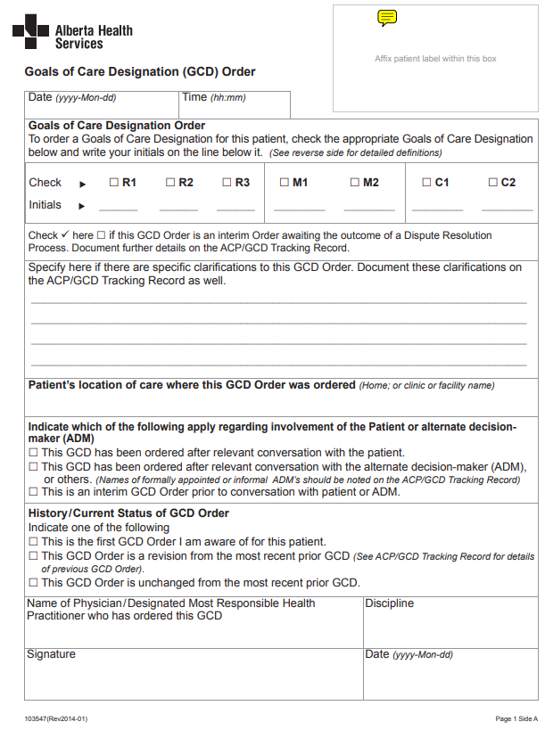
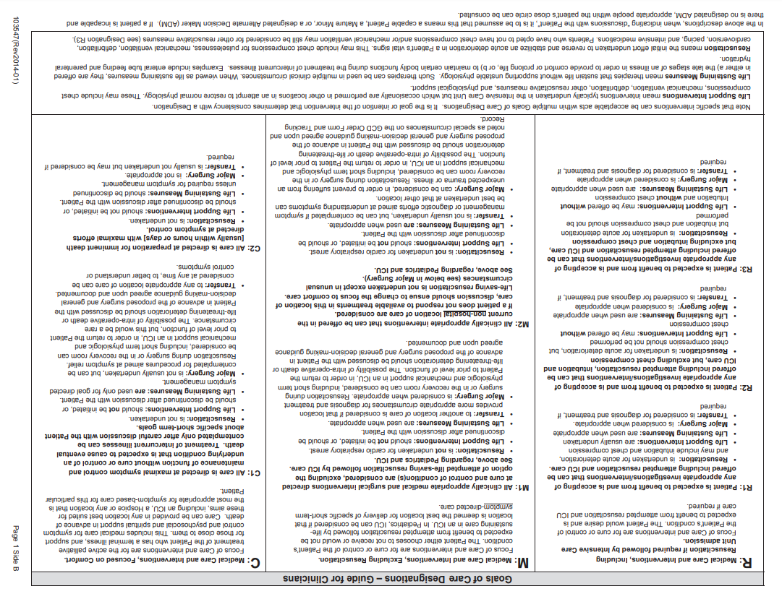

WHEELCHAIR AND WALKER USE AND SAFETY

WHEELCHAIR

Folding the Wheelchair:

Check to see if there are cross bars under the cushion (bars make an “X” – refer to Figure 1). If there are no “X” shaped bars, the wheelchair cannot be folded. If it has cross bars, follow the steps below:
- Remove the cushion.
- If there is a solid backrest, remove the backrest.
- If there is a rigidizer bar connecting the push handles, remove it from the handles (refer to Figures 2 and 3).
- Lift the seat upholstery from the middle and the wheelchair should fold.
Unfolding the Wheelchair:
- Press down on the seat rails (where the seat upholstery is mounted on each side, next to the armrests). Please watch your hands to ensure your fingers do not get caught between the moving bars.
- Secure the backrest and cushion. Make sure the proper side of the cushion is in the front. It is a common mistake to reverse the orientation of the cushion. The zipper of the cover should be at the back, next to the backrest. An improperly installed cushion can have an impact on the comfort of the person and can potentially lead to pressure sores.
- Reattach the rigidizer bar to the push handle on each side (refer to Figures 2 and 3).
When getting onto or off the wheelchair:
- Ensure that the brakes are locked.
- Swing the footplates out of the way (usually done by pressing a lever at the top of the footrest frame). This prevents tripping over the footrests while transferring.
- If the footrest frame does not move out of the way, the foot plate should be flipped to the up position.
- Make sure there is no clutter around the wheelchair when getting onto and off of it.
- Make sure there is nothing around the wheelchair (i.e. blanket, etc.) that the wheelchair user can trip on, slip on, or can cause a misstep when attempting to sit on the wheelchair.
- To provide greater stability the front wheels should be placed in the forward position.
- If the wheelchair has a rigidizer bar that connects the push handles, it must be attached to both sides to give stability to the wheelchair.

Ensure that the wheelchair user is safe and secure when going up or down an incline with the wheelchair.
Anti-tippers (refer to Figure 1) should always be in place to prevent the wheelchair from tipping backwards. Ensure that the wheelchair’s anti-tippers are installed firmly and that the small wheels on the anti-tippers are close to the ground. In the Figure 1, the finger is pointing to the attachment of the anti-tippers (which may look different for different models of wheelchairs) and the small wheels as you can see are close to the ground.

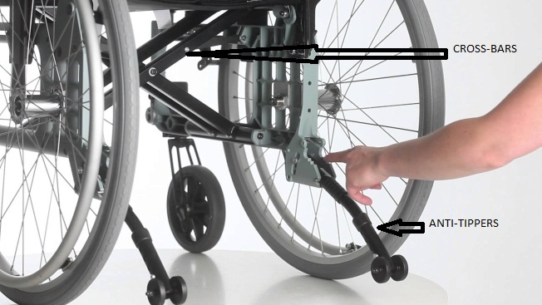Figure 1
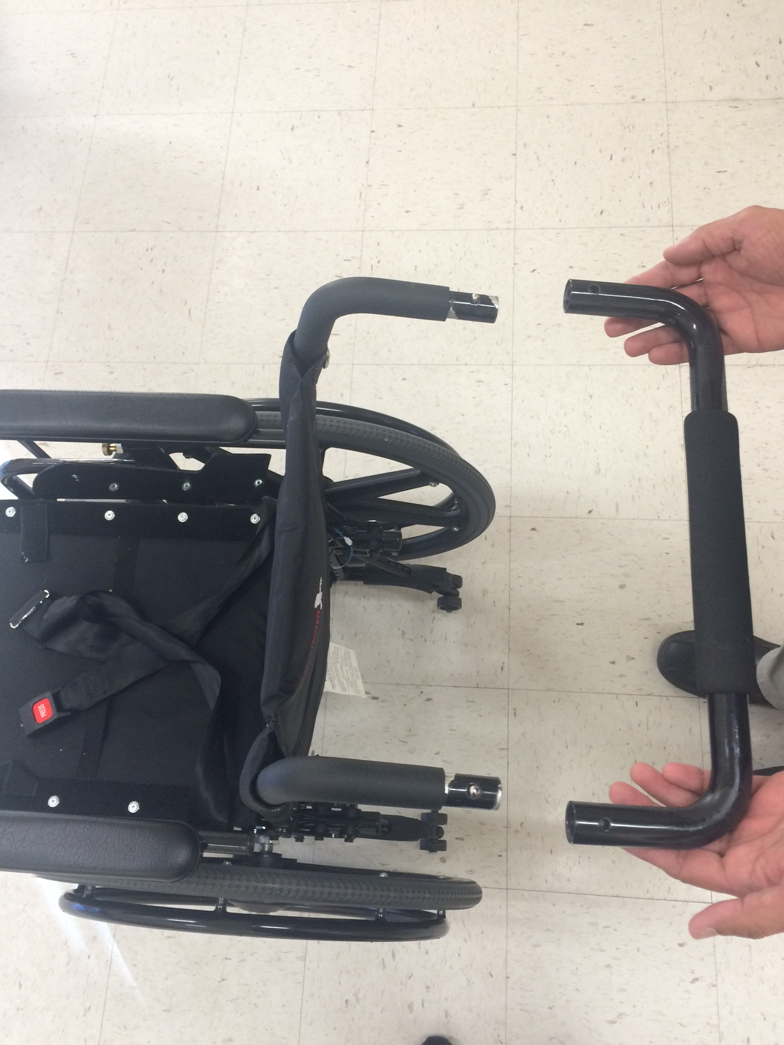
Figure 3
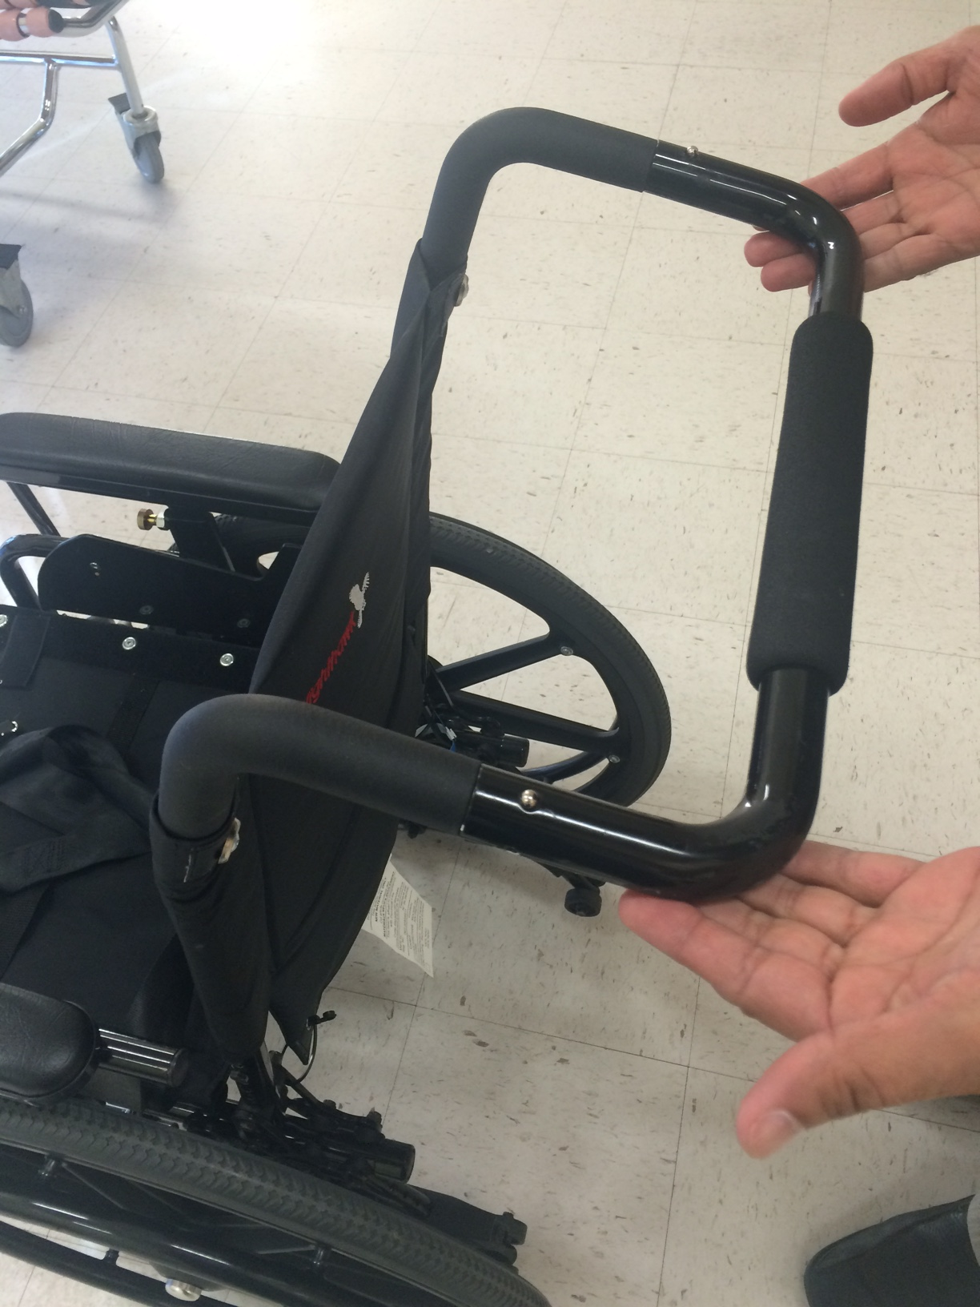
Figure 2

RIGIDIZER BAR
Figure 2
PUSH HANDLES
PRESS ON BOTH SIDES TO RELEASE RIGIDIZER BAR

Please ensure that there are no loose components on the wheelchair.
The wheelchair should be taken into the vendor for yearly maintenance.

WALKER

Getting up to use the walker:

Remember, the walker should not be used to pull yourself up from a seated position. The function of a walker is to assist with walking, and should not to be used as a transfer or lifting device.
- Place the walker directly in front of you.
- Ensure that the brakes are locked.
- When standing up, ensure that the foot of your strongest leg is closest to your body.
- Stand by pushing up from the wheelchair or chair armrests and then hold on to the walker.
If the walker has a seat and you would like to sit on it, make sure that the brakes are on and the front of the walker is up against a wall so that it will not slip out from under you when you are in the process of sitting.

Transferring from walker to a chair, wheelchair or bed:

Do not use the walker to support yourself while sitting down.
If you are transferring to a wheelchair, ensure that the wheelchair brakes are on.

- Back up to the bed or chair until you
- Ensue that the brakes of the walker are locked.
- Reach for the bed or armrests of the chair/wheelchair with your hands.
- Lower yourself, using the support of your legs and hands.
Ensure that the brakes of the walker are in good working order. If they are not, please ask your health care professional for assistance in fixing the brakes.
The above describes the safe use of a four wheeled walker. If you have a two wheeled walker, the same steps apply, with the exception that a two wheeled walker does not have brakes.

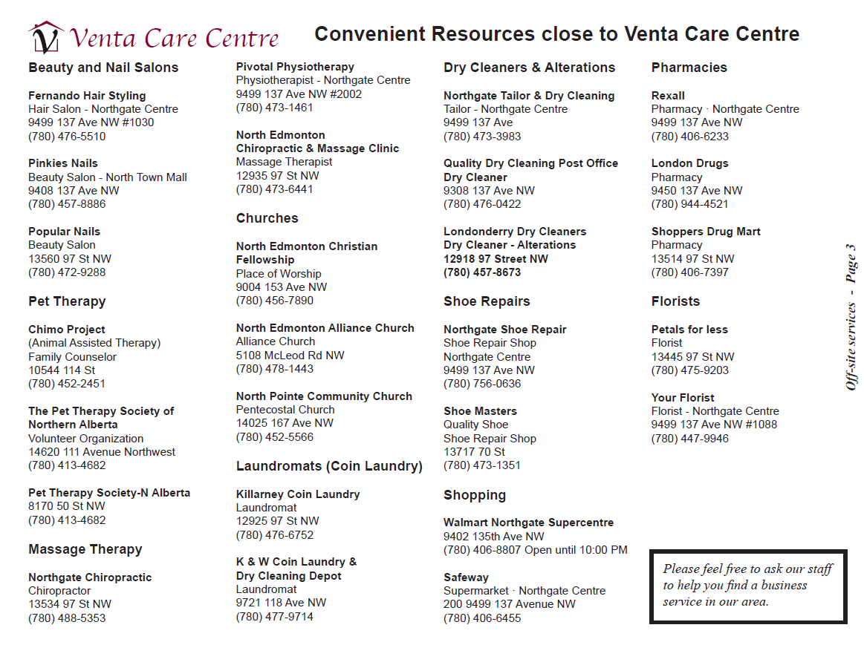

MEET YOUR CARE TEAM
DEPARTMENT / POSITION | STAFF MEMBER | TELEPHONE
CEO | Dr. Peter Birzgalis | 780-377-4401
Administrator | Peter C. Birzgalis | 780-377-4542
Executive Assistant to Administrator | Terra Fleming | 780-377-4415
Reception | Tina Galea | 780-377-4400
Director of Nursing  Assistant Director of Nursing | Helen Doan  Christine Birzgalis | 780-377-2326  780-377-4403
Clinical RN Lead | Gagandeep Sidhu | 780-377-4541
Clinical LPN Lead | Janet Lai | 780-377-4540
First Floor Charge Nurse | Registered Nurse (on duty 24/7) | 780-377-4466
Occupational Health and Safety / Accreditation Coordinator | Sarah Elsokari | 780-476-6678
Registered Dietitian | Teresa Kondratiuk | 780-377-4486
Social Worker | Chanel Mopas | 780-377-4490
Occupational / Recreation Therapy Coordinator  Occupational Therapist | Cecilia Chong  Candie de Grano | 780-377-4414  780-377-4484
Recreation Coordinator | Miranda Mandic | 780-377-4412
Maintenance Services |  | 780-377-4544
Dental Services |  | 780-377-2300



Helping Hands

